Lesson Content
What Standards (national or state) relate to this lesson?  (You should include ALL applicable standards. Rarely do teachers use just one: they’d never get through them all.) | SC.4.P.8.1  Measure and compare objects and materials based on their physical properties including: mass, shape, volume, color, hardness, texture, odor, taste, attraction to magnets.  SC.4.N.1.1  Raise questions about the natural world, use appropriate reference materials that support understanding to obtain information (identifying the source), conduct both individual and team investigations through free exploration and systematic investigations, and generate appropriate explanations based on those explorations.
Essential Understanding  (What is the big idea or essential question that you want students to come away with? In other words, what, aside from the standard and our objective, will students understand when they finish this lesson?) | Students will be able to know the best way to measure the volume objects, whether they are solid, liquid, irregular and regular. Students will understand why we measure different objects a certain way, and be able to apply the concepts learned to real life situations. Students will also understand how carrying out investigations can further clarify information and deepen understanding.
Objectives- What are you teaching?  (Student-centered: What will students know and be able to do after this lesson? Include the ABCD’s of objectives: action, behavior, condition, and degree of mastery, i.e., "C: Given a sentence written in the past or present tense, A: the student B: will be able to re-write the sentence in future tense D: with no errors in tense or tense contradiction (i.e., I will see her yesterday.)."  Note: Degree of mastery does not need to be a percentage.) | Students will be able to:  - Describe the process of measuring the volume of a liquid and compare containers with different volumes.  - Describe the process of measuring the volume of a solid and compare the volumes of different solids.
Rationale  Address the following questions:  - Why are you teaching this objective?  - Where does this lesson fit within a larger plan?  - Why are you teaching it this way?  - Why is it important for students to learn this concept? | - This objective is an important milestone in students’ educations. I believe that being able to measure the volume of objects is a skill needed in other educational areas, such as math as well as higher levels of education. Additionally, this objective is very applicable to students’ lives, as objects in students’ lives all have volumes, whether it is something as obvious as a soda bottle, or something less obvious like a book.  - I believe that the skills utilized in this lesson, including multiplication, addition and subtraction are important skills for students to master, and thus this lesson provides hands on and interactive activities using these skills. Additionally, the process of inquiry and investigation is an important phenomenon to explore as students.  - This lesson combines direct instruction, group work, individual work, pre assessment, formative assessment, summative assessment, media, technology and simulation activities in order to meet the needs of all students by providing various modes of instruction and teaching strategies.
Evaluation Plan- How will you know students have mastered your objectives?  Address the following:  - What formative evidence will you use to document student learning during this lesson?  - What summative evidence will you collect, either during this lesson or in upcoming lessons? | Formative assessment:  - Thumbs up/Thumbs down – This is a great way to assess that students are on track when guiding questions are asked throughout the lesson. Students are often honest with their answers and therefore I think this is effective.  - Checkpoint Questions – These would be asked throughout the lesson to check student understanding and determine if I need to restructure my lesson. For example, questions would be asked after the brain pop video, and during simulation activities.  - Monitoring/Circulating – When students are in their groups working, I will circle around and monitor to ensure that they are on task and in the right direction. I would ensure that conversation is academic based, and that the goals and expectations are being met.  - KWL Chart – Before students watch the brain pop video on day 2, they will complete a KWL chart on what they know and what they want to know. This will be briefly discussed before they watch the video and fill out what they have learned.  Summative Assessment Day 1:  - Measuring Cylinders Activity – As a group, students will investigate the volume of two different liquids, using a measuring cup. Students will then individually fill out charts that include the liquid being measured, and the volume of the liquid. Students will need to include appropriate units.  Summative Assessment Day 2:  - Water Displacement Investigation – Students will work collaboratively in order to determine the volumes of three solids using the water displacement method. Students will record their data in charts given to them.  - Plickers Assessment – Students will individually answer questions based on content taught on day 1 as well as day 2.
What Content Knowledge is necessary for a teacher to teach this material? | - Knowledge of volume  - Knowledge of measuring tools  - How to measure volume of liquid  - How to measure volume of regular solids  - How to measure volume of irregular solids  - Water Displacement Method
What background knowledge is necessary for a student to successfully meet these objectives?  - How will you ensure students’ have this previous knowledge?  - Who are your learners?  - What do you know about them?  - What do you know about their readiness for this content? | - Students will need to understand the concept of taking up space.  - Students will need to know how to multiply, add, and subtract.  - Students will need to know how to read numbers on tools such as measuring cups.  - I believe that my pre-assessment done (see bottom of document) shows students’ background knowledge and readiness for this content.  - Students would need to know how to apply new vocabulary words in new contexts.
What misconceptions might students have about this content? | - Students may confuse the mass and volume of objects.  - Students may believe that heavier objects have a smaller volume.  - Students may not know how to properly read water levels via eyelevel, and thus get inaccurate results.
Lesson Implementation
Teaching Methods  (What teaching method(s) will you use during this lesson? Examples include guided release, 5 Es, direct instruction, lecture, demonstration, partner word, etc.) | - Direct Instruction  - Collaborative Work  - Individual Work  - Technology, such as plickers, brain pop, and the use of projector and powerpoint.  - Investigations  - Table talk discussions
Step-by-Step Plan  (What exactly do you plan to do in teaching this lesson? Be thorough. Act as if you needed a substitute to carry out the lesson for you.)  Where applicable, be sure to address the following:  - What Higher Order Thinking (H.O.T.) questions will you ask?  - How will materials be distributed?  - Who will work together in groups and how will you determine the grouping?  - How will students transition between activities?  - What will you as the teacher do?  - What will the students do?  - What student data will be collected during each phase?  - What are other adults in the room doing? How are they supporting students’ learning?  - What model of co-teaching are you using? | Time  3 minutes  2 minutes  1 minute  3 minutes  1 minute  4 minutes  3 minutes  2 minutes  1 minute  6 minutes  3 minutes  4 minutes  3 minutes  2 minutes  4 minutes  2 minutes  1 minute  5 minutes  2 minutes  2 minutes  4 minutes  3 minutes  10 minutes  1 minute  3 minutes  5 minutes | Who is responsible (Teacher or Students)?  Teacher and Students  Teacher and Students  Students  Teacher and Students  Teacher  Teacher and Students  Students  Teacher  Students  Students  Students  Students  Students  Students  Teacher and Students  Teacher and Students  Teacher and Students  Students  Students  Teacher and Students  Teacher  Teacher and Students  Students  Teacher and Students  Students  Students | Each content area may require a different step-by-step format. Use whichever plan is appropriate for the content taught in this lesson. For example, in science, you would detail the 5 Es here (Engage/Encountering the Idea; Exploring the Idea; Explanation/Organizing the Idea; Extend/Applying the Idea; Evaluation).  Day 1: Measuring Volume of Liquids:  - I will begin my lesson by holding up a water bottle. While holding it, I would say, “I am holding a bottle of water. Suppose I wanted to measure how much space the water in this bottle takes up. Does anyone know the term used for what I would be measuring?” Students will discuss this in their table groups for two minutes and come up with an answer.  - A student from each group would share their answer, and I would write all suggested responses on white board. I would then have the class captain come up, and read the essential question and objective to the class. The class captain will then instruct the class to discuss briefly what we would be learning today.  - I will then point to the definition of volume that would be posted on the wall, and have a volunteer read it out loud.  - I would then ask, “Can anyone tell me when we might need to measure the volume of something in real life?” I would call on volunteers and briefly discuss in order to emphasize the real life application of this lesson. I would then discuss the idea of recipes, and how we need to know an exact measurement.  - I will then show a picture of a pool. I will explain that before the water in this pool was put in, we needed to determine how much water was needed. The amount of water needed to fill this is known as volume.  - I would then ask students to briefly discuss in their tables what volume is usually measured in. I will then have tables share out, and turn to the next side explaining ml and l. (1000ml = 1l) I will ask students to brainstorm and think of examples in which we see ml and l, such as soda, water bottles and so on. I would then ask students questions based on this, such as how many l in 2000ml etc.  - I will then place a measuring cup on each table group, and ask students to observe it for a minute. While they observe, I will ask questions such as, “What are the lines for? How do we determine the volume of a liquid inside?” I would then call on students to discuss these questions.  - I will remind students on the science safety rules, and not to touch any equipment in front of them until instructed. The science safety rules poster would be referenced.  - As a whole group, we will then complete the following simulation activity:  http://www.physics-chemistry-interactive-flash-animation.com/matter_change_state_measurement_mass_volume/volumes_measurement.htm  - Students will then work in groups to measure the volume of two different liquid amounts. They would use a measuring cup, and the two containers of liquid. Students would individually record their results in the chart below.  Liquid Type Volume of Liquid  Day 2: Measuring Volume of Solids  - Students will each be given a KWL Chart. The concept of this would be briefly explained for students who are unfamiliar. I would say, “Now, can I have the class captain come up and tell the class what we would be learning today.” The class captain would come up, read the essential question and objective, and ask the class to briefly discuss in their table groups what they would be doing. Mention that yesterday we did volume of a liquid, and today is volume of a solid.  - Students would be given a few minutes to fill out the “K” and the “W” sections of the chart.  - I will then play the following brainpop video from 2:30 – 3:30 (one minute). I would remind students that they should be taking notes on what they learned in the video, and fill it into their “L” columns.”  https://www.brainpop.com/science/matterandchemistry/measuringmatter/  - I would then call on students to share what they learned from the video, and write these ideas on the board.  - I will then ask, “Raise your hand if you can remember from the video, or from the knowledge that they gained, how we would measure the volume of a regular solid object?” If students are unable to answer, I will demonstrate with my own block, as well as PowerPoint picture.  - I will remind students to think about third grade when they learned about area. I will then ask students, “What is the unit we use for finding area, which is length by width?” I will then ask, “What number do you think we would put up here if it is length by width by height?” I will discuss the idea of cubic units when measuring solids this way.  - I will then tell students that we are going to practice measuring the volume of solids, but first, let us look at a quick song to remind us of all that we have learned. (Stop at 1:25)  https://www.youtube.com/watch?v=LZxXUb9iAZc  - I will then remind students of science safety rules. I will give each table group a cube, a ruler and a worksheet . I will ask students to raise their hand if they need help going over how to use a ruler (use cm side, model starting from 0). They would then fill it out (the length, width, height and volume) and then share their answers. Students will repeat this with another regular object of their choice. I will give students the option of using calculators in their bins, but they can also use their multiplication facts.  - I will then say, “We have just measured the volume of this cube. Thumbs up or thumbs down if you think it was pretty simple to measure the sides. Talk to your shoulder partner.” Have one person share. I will then display a ball of playdoh, and have students talk in their groups for a minute about whether or not it would be easy to measure this object with a ruler, if it has no straight edges.  - I would then say, “Can anyone remember from that brainpop video how we can measure a solid such as this? What was that term?” Displacement – point to definition. One student read, second student read, all students read.  - I would then show steps on power point needed to measure the volume of a solid such as playdoh through water displacement  - Measure volume of water before playdoh  - Measure volume of water after playdoh is in measuring cup  - Subtract the volumes to find volume of playdoh  - I would say, “Let’s test this out again- before we do that. I want us to practice it.” We would then explore the link below. I would remind students about meniscus.  http://cstephenmurray.com/onlinequizes/chemistry/measuring/displacementmethod.htm  (Start at 4th slide)  - Each table group would then be given three measuring tools with volumes of water, as well as three different solid objects. Students will look at this volume and record it. As a group, students will drop ach object into the three measuring tools. Students will measure the volume of the water in each tool when the solid is inside. Subtract the two volumes to find the volume of the solid itself, and record results in chart.  - I will then ask, “Can anyone think of any other objects that we can measure using this displacement method?” – rock, anything irregular.  - Students will then look around classroom and discuss with table groups what objects can we measure using the first method? (Length by width by height), and what objects would be measured using displacement method. We will share some ideas .  - Students will then complete a plickers assessment covering content for both days of lesson.
What will you do if… | …a student struggles with the content?  - Can work with teacher at back of classroom.  - Can get support from table partners during table talks  - Model another example for class
What will you do if… | …a student masters the content quickly?  - Students can help struggling student  - Student would be asked higher order questions that encourage synthesis and application.  - Students would be working cooperatively in heterogeneous groups  - Student can do additional challenge such as measuring the volume of another irregular object found in the classroom.
Meeting your students’ needs as people and as learners | If applicable, how does this lesson connect to the interests and cultural backgrounds of your students?  - I believe that this lesson is interesting to students as volume is something that can connect to every students’ lives, as it is everywhere around them. Additionally, the hands on investigations that these lessons are based around are fun, informative and truly allow students to explore and come to conclusions themselves. Using manipulatives is also exciting for students.
If applicable, how does this lesson connect to/reflect the local community?
- The local community is full of numerous objects, whether liquid or solid that contain volume. Therefore, these lessons provide a direct connection to the real world for students.

How will you differentiate instruction for students who need additional challenge during this lesson (enrichment)?

- Students will be able to measure the volume of different solids, both regular and irregular shapes and record their results. They would find these solids around the classroom, whether it may be a book, or an irregular object such as a pen.

How will you differentiate instruction for students who need additional language support?

- I believe that this lesson plan is ESOL friendly as it is very visual and involves manipulatives which aids in understanding and comprehension for these learners.
- A word wall with all of the new and important vocabulary would be provided for reference throughout the lesson. This word wall would include images that would help the students who need language support understand the content.
- Students will be given sufficient thinking time before having to answer plicker questions, as students who are learning a new language often need this “wait time.”

Accommodations (If needed)  (What students need specific accommodation? List individual students (initials), and then explain the accommodation(s) you will implement for these unique learners.) | - The teacher may work with struggling students to provide extra help  - D.T- Student may need to work with a partner for individual work, or work with the teacher at the back of the classroom for extra help.  - G.Z- For gifted students, more challenging questions would be asked. “Student teacher” can also be implemented.
Materials  (What materials will you use? Why did you choose these materials? Include any resources you used. This can also include people!) | - Laptop  - Projector  - Elmo  - Measuring Cups  - Cubes  - Worksheets  - Playdoh  - Ruler  - Plicker Cards  - Cell Phone for Plicker Application  - Calculator  - Solid Objects  - Regular solid object of student choice.

Pre-Assessment Results – See Table and Bar Graph Below

- = Answered Correctly
- = Answered Incorrectly

 | What is Volume? | What is a good tool to measure volume? | How do we measure the volume of a solid? | What is the best way to measure the volume of a rock? | What is the unit we use for volume?
Martha
Rachel
Stefanie
Gerry
Raquel
Jesse
Samantha
Lily
Stella
Wesley
Anthony
Shane
Lizzy
Charlie

From these pre-assessment results, it is evident that most students have minimal background knowledge on the topic of volume, and thus I must start from the basics. This is important information to know, as I am now more aware of how to construct my lesson, and know exactly what information students need. However, it seems that students have background knowledge about measuring tools, and it can be assumed that they were either exposed to this in their real life situations, or in other content areas. Thus, I know that I do not have to make the different measuring tools a focus of my lesson, and can quickly refresh their memories instead. All but 3 students know how to measure the volume of a solid, and thus this must also be explained, modeled and practiced explicitly throughout my lesson.
This is the same for the idea of water displacement. I believe that the two students who got this question correct simply guessed, as it is highly unlikely that they would have been exposed to this concept previously. Thus, I must put a lot of emphasis on this new vocabulary word, and be sure that students grasp the concept. In terms of units, the majority of the class answered this correctly, showing that they have been exposed to this concept before. Again, I know now not to spend too much focus on this in my lesson.
Post-Reflection Results

How does the displacement method work?

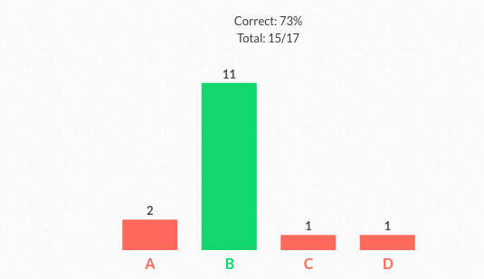

Which of the following objects would the displacement method be best for measuring volume?

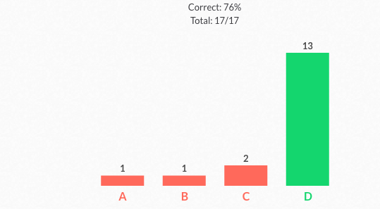

What units do we use to measure the volumes of solids?

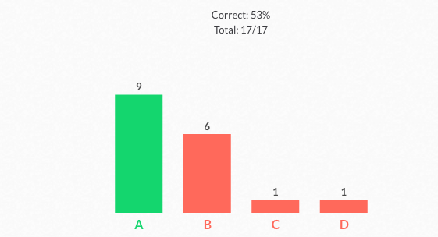

How can we measure the volume of an irregular shape, such as a rock?

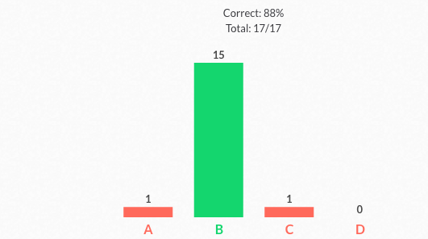
How can we measure the volume of rectangular, or regular solid objects?

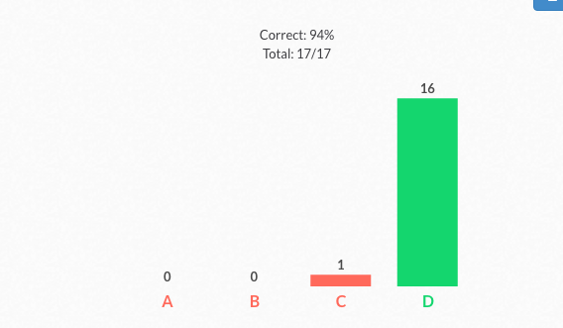

What is a good tool for measuring volume?

What is volume?

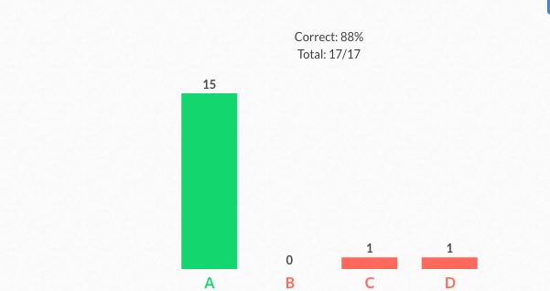

Reflection

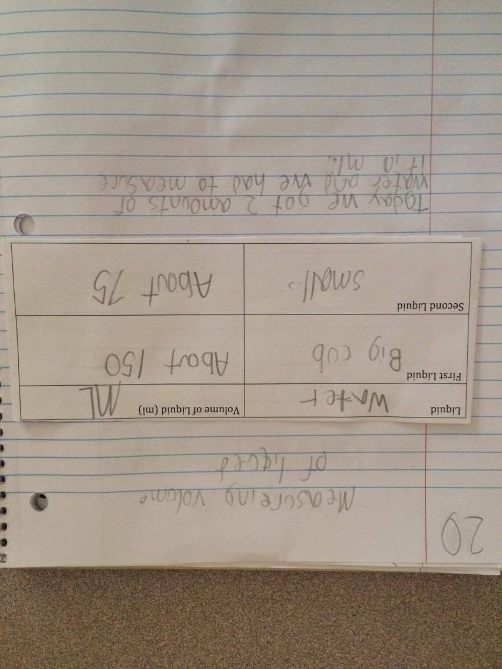
The structure of this connected lesson was very helpful and informative for me. Firstly, the use of pre-assessment results informed my decisions when constructing my lesson plan. (See pre-assessment data and analysis on page 21). I knew what topics to focus on, as well as what topics (such as measuring tools) only needed to be taught in a review style. Day 1 of my connected lesson focused on exploring volume, and measuring the volume of liquids. I believed that teaching this lesson on day 1 was a great way to introduce the topic, assess students as well as scaffold them for the lesson on day 2. From the post-assessment results, it is evident that 88% of students mastered the concept of what volume is, and 94% are aware of measuring tools used. Students also completed science journal entries, in which they shared their results of measuring liquids in measuring cups (See Photo). 100% of student journals met my object, with all including accurate measurements, as well as a brief summary of what was done that day. I believe that one of my strong points from this lesson was connecting it to real life situations (7:52 in video), as well as facilitating a lot of open discussion. I also believe that my formative assessment when circulating was effective, as I was able to truly engage in conversation and gain insight into students’ thought processes (12:16 in video). I also made a conscious effort to connect this lesson to other content areas such as Math, so students can see the interdependence of content areas, and why this topic is important. I believe that my classroom management was effective, using methods such as attention getters (6:32 in video), proximity control (11:22) and non verbal cues such as change in stance and eye contact (22:19).
After day 1, I was able to make adjustments for day 2. Some of these included clearer instructions, projecting the instructions on screen, as well as giving students more trials when measuring the solids. I believe that the multiple trials were a great adjustment, and allowing students to measure their own objects was an effective differentiation for method. For example, in my video, two higher level learners remained engaged while measuring other objects, rather than waiting for further instruction, or being bored (24:16). In this lesson, 94% of students mastered the concept of measuring regular solids, and they were able to write a science journal entry with answering a higher order-thinking question, involving the methods of measuring both regular and irregular solids. 90% of students met this object by using specific vocabulary, explaining their thinking and answering the question in its entirety. Surprisingly, the post assessment data showed that only 53% of students knew the unit for measuring volume of solids, which did not align with pre-assessment results. This indicates that I needed to spend more time on it, and try different methods of teaching when explaining it. However, I do believe that bringing their background knowledge of area that they would have learned in the third grade was effective to an extent. From watching the video, I was able to see room for improvement. Firstly, students had difficulty writing notes in their KWL chart while simultaneously watching the brain pop video (6:26) Thus, I believe that students needed time to write, so in the future I would pause the video. Additionally, I can give students hints, and say things such as “This is something you may need to write down.” This would give students thinking time, as well as time to digest all the new information they were being exposed to. However, from the video, I can see that students learned a lot from the brainpop and were effective note takers. Students also wrote down ideas that they heard from other students, expanding their knowledge (8:16) I believe that all of my transitions went smoothly, and that preparing all materials ahead of time significantly improves classroom management, and students are more on task and have more time for learning. However, in the video, I saw that a student came close to spilling water on the computer (35:45). Thus, in the future, I will give each table large containers of water and allow them to pour the liquids into the containers themselves, allowing them to choose their own starting volume. This would also give them more independence and hands on learning. From reflection and collaboration with other professionals, I am now aware that I should have had students know exactly how I would know if they had met this object. Ensuring that they know this information makes it more likely for them to meet my objectives. Furthermore, I believe that I should have focused more on the breakdown of new vocabulary words, as some students did not fully register the new word. For example, at time in the video, (40:12) a student still did not grasp the word displacement, though she understand the process behind it. Nevertheless, the connected lesson was a great learning experience and allowed me to grow professionally in a variety of ways.

CT NOTES:
